79.03.17
From Charles Fawcett
RB MSS M7, Library, Royal Botanic Gardens Melbourne.

Ballina. 17 March. 79.
My dear Baron,
I was this day brought an orchid in rather an imperfect state. It grows in clefts or holes of trees, described as white. The leaf & flower resemble the Calanthe which grows in moist brushes, but commonly I think called "Mountain Lily". But it has stipules all along the stem and the fruit capsule is much smaller and is strangely protected. They are not now in flower, so there is no getting any more this season. The person who brought it told me of another of which he has seen but one, on a tree very high up — and it seems they fired at it to get some of the flowers. He described it as a huge flower, white and as big as a large basket (in the room) about 3 ft. long & 18 in. high. Is anything like this described? It may be what Mr. Fitzgerald wants — but, if it is not described I should like you to get it first. From what I could learn it would not be in flower till September — The same man is in a great way about what poisons the cattle down here. (I know cattle & horses have died from eating the beans I mentioned & I have known geese poisoned by the nuts of the Zamia) This man is of opinion that it is the berries of the Sponia aspera which are the cause. Do you think so? & would there be any way of having the berries analyzed? If the Randia has odoriferous flowers, it might be worth growing for ornament. The tree from which the fruit came was 18 ft. & there are larger — but, only, as far as I know, in one small, low-lying patch of brush. The people who work all about did not know anything about it. I send this orchid with some other specimens. I am sorry to say our Steamer will be stuck in behind the bar until the high tides, so this goes by the Clarence.
I am, My dear Baron,
yrs truly
Charles H. Fawcett.

P. S. If you can do it in a few words, and without much trouble, kindly let me know the difference between a dendrobium and a bolbophyllum. I have sent you only one (without flower) besides the B. minutissima — but there is, I think, another up the river, resembling the one I now refer to (B. exignum) — There is also, I hear, up the river, in a place difficult of access something like a huge terrestrial orchid or liliaceous plant, with a tall flowering stem, and the leaves flattened out something like the New Zealand flax — in flower about Christmas —
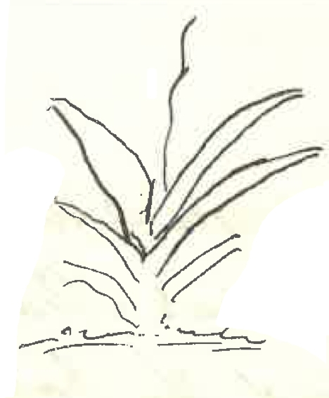
Baron Ferd. von Mueller.
&c &c &c.

MS found with a specimen of Calanthe triplicata (MEL 2258045). MS annotation by M: 'Calanthe'.
NSW.
Clarence River, NSW?
one and (B. exignum), below, are both marked with a cross.
B. exiguum?
There is a small sketch around which the final three lines are written: 79-03-17_image01.jpg

